OIL SPILL DETECTION

Kunal Borse | Dheeraj Nair | Rugved Shete | Vilas Khedkar
kunal.borserao@gmail.com | dheerajnairp@gmail.com | rugved.shete004@gmail.com. | vilas.khedekar@mituniversity.edu.in
Student | Student | Student | Assistant Professor
School of Computing | School of Computing | School of Computing | School of Computing
Computer Science | Computer Science | Computer Science | Computer Science
and Engineering | and Engineering | and Engineering | and Engineering

Abstract- Oil spills are major environmental disasters, threatening marine life, coastal economies, and public health. Rapid and precise detection is crucial for minimizing their impact. This study examines cutting- edge technique for oil spill identification: a machine learning and deep learning-based image processing system using drone-captured imagery. The paper explores data collection, algorithmic approaches, and performance evaluations. Findings indicate that merging these techniques enhances detection reliability and facilitates quicker emergency responses.

Keywords- Oil Spill Monitoring, Remote Sensing, SAR Technology, Unmanned Aerial Vehicles (UAVs), Machine Learning, Environmental Protection.

INTRODUCTION
Marine oil spills, whether accidental or deliberate, present severe ecological and economic challenges. Events like the Deepwater Horizon spill highlight the need for efficient detection and mitigation strategies. Conventional monitoring techniques, such as manual inspections and optical imaging, are often ineffective in poor weather or low-light conditions.
Emerging remote sensing technologies offer two synergistic solutions:

Drone-based image analysis:
High-resolution cameras on UAVs, combined with deep learning models, classify oil spills and
distinguish them from similar features (e.g., algae or shadows).
- SAR-based monitoring: SAR systems detect oil slicks by analyzing radar backscatter variations, functioning independently of
daylight or cloud cover.
This paper reviews both methodologies, discussing their implementation, challenges, and potential for a combined detection framework.

LITERATURE SURVEY

  - UAV-Assisted Image Processing
Recent advancements employ machine learning to identify oil spills in aerial images. For instance, research in Oil Spill Detection via Image Processing introduces a deep convolutional neural network (DCNN) model integrated with Pipeline ML. UAV-captured images are segmented, classified, and analyzed to detect different spill types (e.g., surface spills, contaminated soil, crude oil patches).

  - SAR-Based Oil Spill Detection
SAR outperforms optical sensors by operating in all weather conditions. NASA ARSET training materials explain that oil slicks appear as dark regions in SAR images due to suppressed capillary waves. Detection efficiency depends on polarization, frequency bands (X, C, L), and incidence angles. Techniques like damping ratio calculations and multi- polarization analysis help estimate slick thickness and differentiate spills from false positives (e.g., biogenic films or low-wind zones).

  - Synergizing UAV and SAR Methods
Each approach has unique benefits and drawbacks. UAV imaging delivers fine spatial detail but is weather-dependent. SAR provides consistent, wide-area coverage but requires complex signal processing. Integrating both can enhance accuracy by cross-validating results, offering a more resilient monitoring solution.

RESEARCH PAPERS

"Oil Spill Detection and Classification through Deep Learning and Tailored Data Augmentation"
    - Link: https://www.sciencedirect.com/science/article/ pii/S1569843224001997

Main Points:

      - Introduces a deep learning model with a dual attention mechanism to enhance oil spill detection and classification using aerial imagery.
      - Utilizes a tailored data augmentation method based on Generative Adversarial Networks (GANs) to improve model accuracy.

o Achieves a mean Intersection over Union (mIoU) of 72.49%, with data augmentation contributing to a 2.56% increase in mIoU.
Provides a feasible solution for detecting and classifying oil spills, aiding marine environmental managers in timely decision-making.

"A Review of Oil Spill Remote Sensing"

    - Link:https://www.mdpi.com/1424- 8220/18/1/91

Main Points:

      - Discusses various remote sensing techniques for oil spill detection, including satellite radar systems and image processing methods.
      - Highlights challenges such as distinguishing oil spills from look- alikes and the impact of environmental factors on detection accuracy.
      - Emphasizes the importance of timely and accurate detection for effective emergency response and environmental protection.

"A Deep-Learning Framework for the Detection of Oil Spills from SAR Data"
    - Link:https://www.mdpi.com/1424- 8220/21/7/2351

Main Points:

      - Proposes a two-stage convolutional neural network (CNN) framework for classifying and segmenting oil spills in Synthetic Aperture Radar (SAR) images.
      - The first stage classifies image patches based on oil spill presence, while the second stage segments significant oil spill instances.
      - Achieves high accuracy (99%) in classification and a Dice score of 80% in segmentation, outperforming state- of-the-art architectures.

METHODOLOGHY

UAV Image Analysis Framework
The proposed system operates in two stages:

Training Phase:
      - Data Collection: UAVs capture images over spill-prone zones, including rivers and coastlines, covering various spill scenarios.
      - Preprocessing: Images are resized, segmented, and normalized. A machine learning pipeline is built using ML.NET.
      - Model Development: CNNs are trained on labeled datasets, with performance assessed via accuracy, precision, recall, and F1-score.

Deployment Phase:
      - Real-Time Detection: Live UAV feeds are processed to classify spills and pinpoint locations using GPS.

SAR Data Processing Workflow
Key steps in SAR-based detection include:
    - Data Acquisition: Satellites like RADARSAT-2 collect SAR imagery over marine regions.
    - Preprocessing: Noise reduction, speckle filtering, and radiometric calibration are applied.
    - Feature Extraction: Backscatter intensity, damping ratios, and polarimetric data distinguish oil from water.
    - Classification: Thresholding and machine learning algorithms automate slick identification and tracking.

Integrated Monitoring System
A hybrid approach merges UAV and SAR data:
    - Data Fusion: Aligns UAV and SAR datasets spatially and temporally.
    - Hybrid Algorithm: Combines UAV’s high-resolution classification with SAR’s all-weather detection.
    - Operational Deployment: UAVs conduct detailed inspections while SAR ensures continuous surveillance.

PROBLEM DEFINITION
Oil spills threaten marine ecosystems, coastal communities, and economic activities, requiring immediate and precise identification for timely response. Current detection systems face significant challenges: optical sensors are ineffective during poor weather or nighttime, while manual surveillance is slow and labor-intensive. Unmanned aerial vehicles (UAVs) provide detailed imagery but have limited coverage and weather constraints. Synthetic Aperture Radar (SAR) enables all-weather monitoring but suffers from false alarms and complex data analysis. The lack of an integrated system combining these technologies results in delayed decision-making and inefficient resource deployment. This research investigates how to synergize UAV and SAR capabilities to develop a more reliable, comprehensive, and rapid oil spill detection framework that overcomes existing limitations in environmental monitoring.

PROPOSED METHOD

PROPOSED SYSTEM ARCHITECTURE

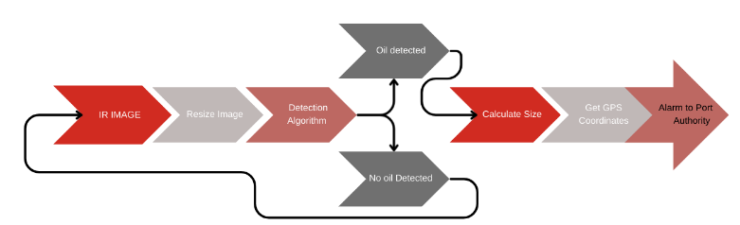
1. IR Image: The system begins by capturing an infrared image, which is typically used to detect temperature differences that can indicate oil spills on water.
2. Resize Image: The captured image is resized to make it manageable for further processing.
3. Detection Algorithm: A detection algorithm is applied to the resized image to analyze and identify whether there is an oil spill present.
4. Oil Detected / No Oil Detected:
- If oil is detected, the system proceeds to calculate the size of the spill.
- If no oil is detected, the process ends.
5. Calculate Size: The system calculates the size of the detected oil spill to assess the severity of the incident.
6. Get GPS Coordinates: The system retrieves GPS coordinates to pinpoint the exact location of the oil spill.
7. Alarm to Port Authority: Finally, an alarm is sent to the Port Authority to alert them about the oil spill, enabling them to take appropriate action.

DESCRIPTION OF THE PROJECT
This research develops an innovative oil spill detection framework by integrating unmanned aerial vehicle (UAV) imaging with satellite-based synthetic aperture radar (SAR) technology. The system aims to overcome key limitations in current monitoring methods by combining high-resolution visual detection with all- weather radar surveillance capabilities.
The project addresses two critical challenges in marine environmental protection:
- the inability of optical sensors to operate in poor weather conditions,
- the limited coverage area of conventional surveillance methods,
Our solution leverages machine learning algorithms to process multi-source remote sensing data, enabling accurate identification and classification of oil slicks across varying marine conditions.

The developed system will provide environmental agencies with a reliable tool for early spill detection, supporting timely containment efforts and minimizing ecological damage. By combining the strengths of different remote sensing platforms, this project advances the state-of-the-art in marine pollution monitoring technology.

This initiative creates a next-generation oil spill tracking solution by merging drone cameras with space radar imaging. The technology automatically spots and maps oil leaks in oceans using artificial intelligence that studies both close-up photos and wide radar scans. It works day and night, in clear or stormy weather, helping coast guards and environmental teams find and clean spills faster. The smart system learns from each detection, constantly improving its ability to tell real spills from natural water patterns. This breakthrough helps protect beaches, sea animals and fishing industries by catching pollution early when it's easiest to clean.

DESIGN AND IMPLEMENTATION

Contains Several Steps:
- Load Data: The initial step involves importing the raw data into memory for further processing.
- Build a Processing Pipeline: A sequence of operations is defined to transform data and facilitate machine learning model training. ML.NET provides various transformation techniques, such as one-hot

encoding, along with a selection of machine learning algorithms.
- Train the Model: Once the pipeline is set up, the training process begins using the Fit() method, which enables the model to learn from the provided dataset.
- Evaluate Performance: The model's effectiveness can be assessed at any stage, allowing for adjustments and improvements based on evaluation results.
- Save the Model: After successful training, the model is stored as a file for future use. The application consists of two microservices: one for training and evaluating the model, and another for deploying it for predictions.
- Load for Predictions: The saved model can be retrieved and applied to make predictions on new data when required.
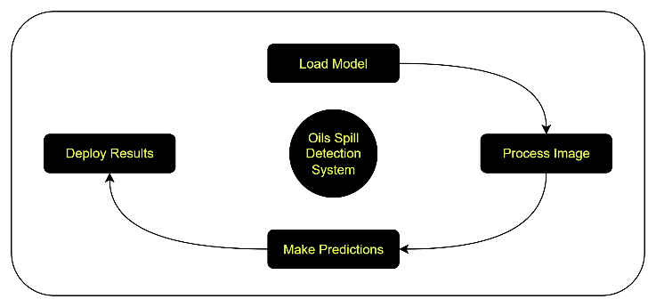

Our innovative oil spill monitoring solution combines aerial drone imaging with satellite radar technology. The system architecture employs a multi-layered processing approach that synergizes visual and radar data to overcome the limitations of conventional detection methods. This integrated design enables reliable spill identification across various environmental conditions while minimizing false alarms.

Optical Detection Component Implementation
The visual analysis subsystem processes high- resolution drone imagery through a specialized neural network architecture. Our custom deep learning model, built upon an enhanced YOLO framework, incorporates spectral analysis modules specifically designed for marine conditions. The preprocessing stage applies adaptive contrast enhancement and multi-scale noise reduction techniques to improve detection of subtle oil signatures. Unique to our approach is the incorporation of hyperspectral band analysis

Radar Signal Interpretation System
The radar processing component utilizes advanced synthetic aperture radar (SAR) analytics with novel feature extraction algorithms. Our methodology goes beyond standard backscatter analysis by implementing a multi-dimensional feature space incorporating texture, polarization, and temporal change metrics. The system employs an innovative two-phase detection protocol: initial candidate identification through adaptive thresholding followed by sophisticated machine learning classification. This dual-stage approach significantly reduces computational load while maintaining high sensitivity to actual spill events.

CONCLUSION

Combining UAV imaging and SAR technology creates a robust solution for oil spill detection. UAVs provide detailed visuals, while SAR ensures uninterrupted monitoring. This synergy improves accuracy and speeds up response times, critical for environmental protection. Future advancements in AI and sensor tech will further refine these systems, enabling more effective spill management.

REFERENCES
- Wikipedia.
- Jiao, Z., Jia, G., & Cai, Y. (2019). Deep Learning and UAVs for Oil Spill Detection. Computers &
Industrial Engineering.
- Falqueto, L. E., et al. (2019). Oil Rig Detection via CNNs in SAR Imagery. IEEE Geoscience and Remote Sensing Letters.
- Holstein, A., et al. (2018). Caspian Sea Oil Spill Monitoring with SAR. Environmental Earth Sciences.
- De Kerf, T., et al. (2020). Machine Learning for Infrared-Based Spill Detection. Remote Sensing.
- NASA ARSET (2022). SAR for Disaster Management: Oil Spills.
- Z. Jiao, G. Jia, and Y. Cai, “A New Approach to Oil Spill Detection that Combines Deep Learning with Unmanned Aerial Vehicles,” Computers & Industrial Engineering, vol. 135,
pp. 1300-1311, 2019.
- T. De Kerf, J. Gladines, S. Sels, and S. Vanlanduit, “Oil Spill Detection Using Machine Learning and Infrared Images,” Remote Sensing, vol. 12(24), 2020.

